Practical 1 :Write a React JS program to create a Counter Application using Redux. The application should provide Increment, Decrement, and Reset buttons and maintain the counter value in the Redux store.
Hints:
- Create Redux actions and action creators.
- Create a reducer to handle counter actions.
- Create a Redux store.
- Connect the React component with Redux.
- Display the current counter value.
- Use @reduxjs/toolkit or traditional Redux concepts. The basic flow is:
Component → Dispatch Action → Reducer → Store → Component
CODE:
OUTPUT:
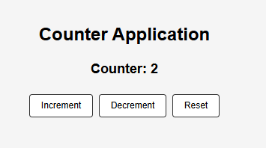
Practical 2 :Write a React JS program to develop a Food Items List Application using Redux. Store a list of food items in the Redux store and display them on the webpage.
Hints:
- Create a Redux store containing food items.
- Display food name, category, and price.
- Add an option to add a food item.
- Add an option to remove a food item.
- Use Redux actions and reducers for state management.
- Create actions such as ADD_FOOD and REMOVE_FOOD. Maintain the food array inside the reducer.
CODE:
OUTPUT:
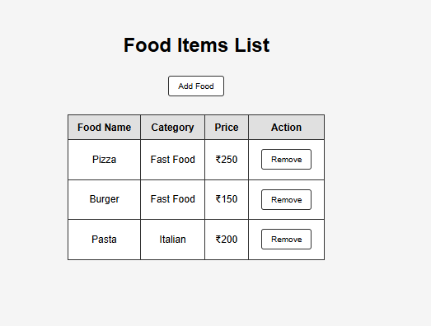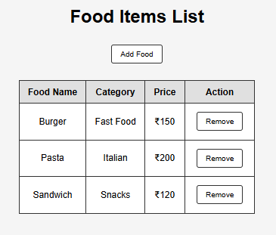
Practical 3 :Write a React JS program to fetch food items asynchronously and display them using Redux. The application should show suitable messages while data is loading or when an error occurs.
Hints:
- Fetch data from an API or simulate an API using setTimeout().
- Maintain loading, data, and error states in Redux.
- Display a loading message while fetching.
- Display food items after successful fetching.
- Display an error message if fetching fails.
- Use three actions:
FETCH_FOOD_REQUEST
FETCH_FOOD_SUCCESS
FETCH_FOOD_FAILURE
CODE:
OUTPUT:
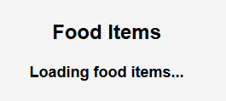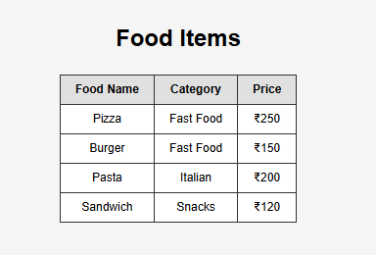
Practical 4 :Write a React JS program to develop a News Application using Redux and Promise Middleware. Fetch news data asynchronously and display the news articles.
Hints:
- Create Redux actions for fetching news.
- Use Promise Middleware to handle asynchronous operations.
- Display the title and description of each news article.
- Display a loading message while the request is in progress.
- Handle API errors.
- A promise-based action can have the following flow:
Dispatch Request
↓
Promise/API Call
↓
Success / Failure
↓
Reducer
↓
Redux Store
↓
React Component
CODE:
OUTPUT:
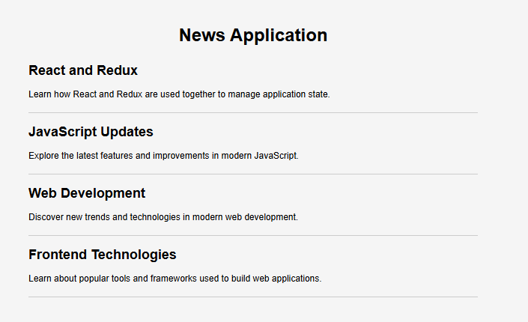
Practical 5 :Write a React JS program to demonstrate the use of Redux Middleware by creating a custom Logger Middleware. The middleware should display the dispatched action and the previous and next state in the browser console.
Hints:
- Create a Redux store.
- Create a counter reducer.
- Create custom logger middleware.
- Log the action before it reaches the reducer.
- Log the state before and after the action.
- Redux middleware follows the pattern:
const logger = store => next => action => {
// middleware code
return next(action);
};
CODE:
OUTPUT:
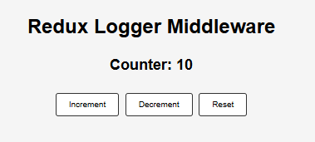
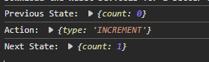

Practical 6 :Write a React JS program to develop a Product List Application using Redux-Saga Middleware. Fetch product information asynchronously and display the products.
Hints:
- Create Redux actions.
- Create a reducer for product data.
- Create a Saga to perform the API request.
- Use call() for the API request.
- Use put() to dispatch success/failure actions.
- Display product name and price.
- The basic Saga workflow is:
Component
↓
Dispatch FETCH_PRODUCTS
↓
Saga watches action
↓
call(API)
↓
put(SUCCESS / FAILURE)
↓
Reducer
↓
Store
↓
Component
CODE:
OUTPUT:
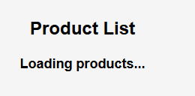
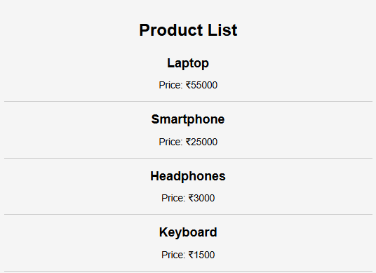
Practical 7 :Write a React JS program to create a Product Search Application using Redux-Saga. Allow the user to enter a product name and fetch/display matching products.
Hints:
- Provide a search input box.
- Dispatch a search action when the user searches.
- Handle the API request using Redux-Saga.
- Display loading, success, and error states.
- Display the matching products.
- Use Saga methods such as:
takeLatest()
call()
put()
takeLatest() is useful because only the latest search request needs to be processed.
CODE:
OUTPUT:
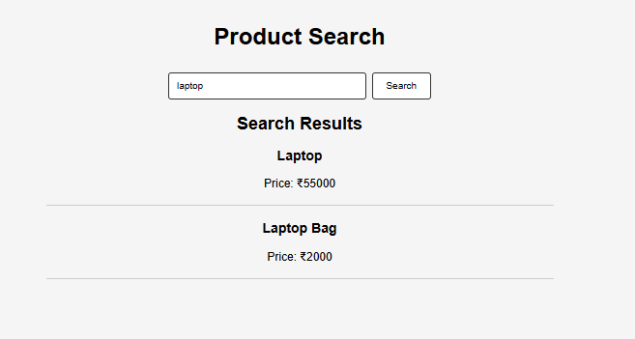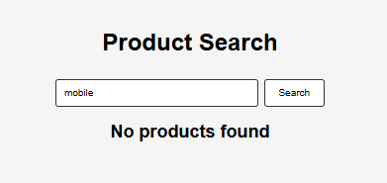

Practical 8 :Write a React JS program to develop a Product List and Shopping Cart Application using Redux and Redux-Saga. Display products and allow users to add products to a shopping cart.
Hints:
- Fetch products using Redux-Saga.
- Display product name, price, and image.
- Provide an Add to Cart button.
- Store cart items in Redux.
- Calculate and display the total cart price.
- Handle loading and error conditions.
- Maintain separate Redux state for:
products
cart
loading
error
Use call() for asynchronous operations and put() to update Redux state.
CODE:
OUTPUT:
